

**CHILDCARE HYGIENE SUPPLIES**  
Freephone: 0508 467 462  
Fax: 09 427 4413  
Email: sales@insinc.co.nz  
www.childcaresupplies.co.nz

**Insinc Products are specialist suppliers of eco-friendly and sustainable   
cleaning and hygiene products.**

***What this means to you:***  
The products in our environmentally friendly range are safe for your health and gentle on the environment. Green Earth cleaning products are designed for commercial use and get the job done as well as, if not better than traditional cleaning chemicals, without the toxic fumes and residue. Recycled paper products are soft to use, and are oxygen bleached rather than chlorine bleached so do not contain harmful chemicals.

***Our range includes:***   
Green Earth cleaning products – all natural, non-toxic, biodegradable, Environmental Choice  
Earthcare toilet paper – 100% recycled paper, Environmental Choice  
Earthsmart toilet paper and paper towels – 100% recycled paper   
Coastal toilet paper and paper towels – 100% and 50% recycled

**CLEANING PRODUCTS**

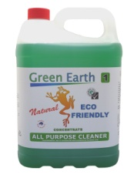

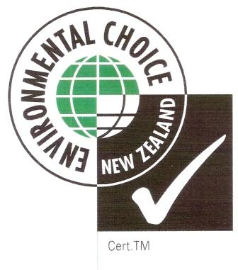



**Glass and Surface Cleaner** - cleans and sanitises at the same time. It is an all natural environmentally friendly product used to clean glass, mirrors and most hard surfaces without leaving anything behind – like harsh chemical fumes or residue. Natural way to get a streak-free clean.

5L concentrate $22.04 20L concentrate $76.80

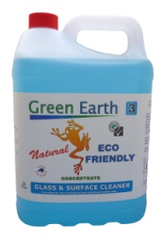



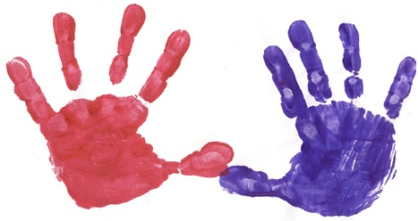 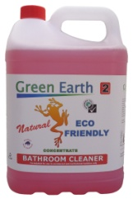



**Bathroom Cleaner** - formulated to cut through soap scum, hard water and rust, leaving vanities and bathrooms naturally clean. Green Earth’s bathroom cleaner contains natural citric acid for an extremely effective lime scale removal. The fresh plant based fragrance leaves bathrooms and restrooms sparkling clean!

5L concentrate $25.94 20L concentrate $94.40

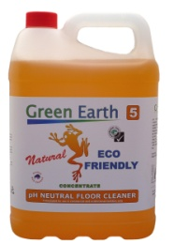



**Floor Cleaner** - concentrated product that cleans floors without duling the finish - with no rinsing necessary. Floor Cleaner has a neutral pH that is designed to dry without streaking. That means no rinsing is necessary after use and can be used on all types of flooring that is not harmed by water. Use on waxed floors without concern for dulling the finish. It also deodorizes as it cleans with a fresh spice scent.

5L concentrate $24.06 20L concentrate $89.44

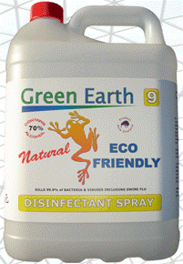

**Sanitiser Alcohol** - An ecologically sound, environmentally conscious, broad germicidal activity disinfectant containing 70% ethyl alcohol. Green Earth alcohol sanitiser spray is a hospital grade disinfectant that is extremely effective in killing 99.9% of all Bacteria’s and Viruses including influenzas such as swine and bird flu.

5L ready to use $28.13 20L ready to use $98.75

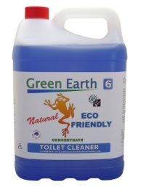



**Toilet Cleaner** - extra thick Toilet bowl cleaner performs three-steps in one process—it cleans, disinfects and deodorizes. The thick liquid is thickened with a natural eco-friendly thickener which allows the cleaner to cling to surfaces for longer to remove stubborn rust and mineral deposits. Contains natural citric acid to help remove even the most stubborn stains.

5L concentrate $29.84 20L concentrate $112.44

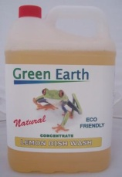

**Dishwashing Detergent** - Lemon dishwashing liquid is manufactured from natural plant extracts, is 100% biodegradable, free rinsing and leaves dishes and eating utensils sparkling and "Squeeky Clean"

1Litre $7.50 5Litres $26.00

Disinfectant Cleaner – cleans and disinfects at the same time. Kills all bacteria and viruses at concentration above 1:50. Eco-friendly surfactants and eucalyptus oil for fresh smelling highly effective clean plus quat disinfectants to kill all germs. Clean bathrooms, toilets, kitchens and any surfaces requiring disinfecting.

5L concentrate $16.50

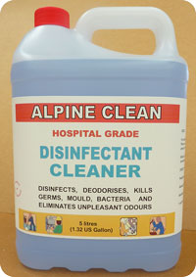

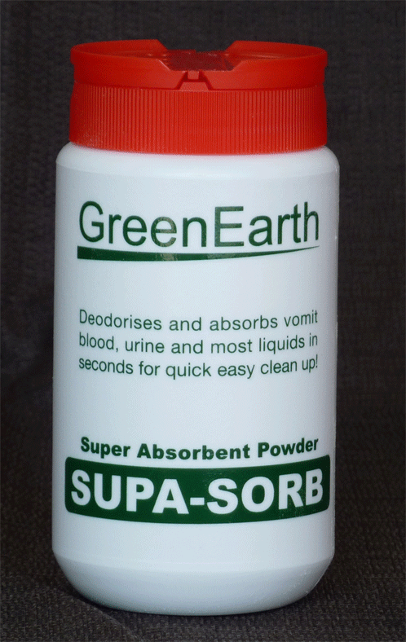

**Supa-Sorb** - super absorbent powder does the unpleasant job of removing vomit, diarrhoea and pet mess off your carpets & floors and helps prevent damage. SupaSorb absorbes over 100 times it's own weight, is non-toxic, made from natural products and is also biodegradable making it safe to use. Deodorant that elimates odours. Sprinkle on and vacuum or sweep up.

225g shaker $12.35

**HAND CARE**

**Liquid Hand Wash -** gentle liquid soap with almond oil and lanolin to clean and protect your hands. This hand cleanser is free of any harsh chemicals, and softens hands with lanolin. Natural Liquid HandWash soap from GreenEarth is tough on grime, but easy on your hands. A totally natural liquid handwash soap formulated from natural palm oils, coconut oils, and enhanced with fragrance almond oils.

5Litres $24.38 20L $93.75

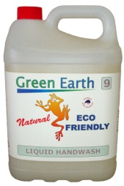



[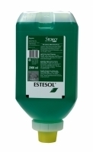](http://www.daltoninternational.co.nz/media/product/1581_original_size_1580_original_size_88331106.jpg)

**Disposable Gloves** – Powdered or Unpowdered. Carton of 10 x boxes of 100gloves (1000 gloves)

Latex Powdered $75.00 Vinyl Powdered $59.88  
Latex Unpowdered $89.50 Vinyl Unpowdered $71.86

**Pouch soap –** Estesol soap free skin cleanser. 1000 washes per soft bottle.

2000ml soft bottle $34.68 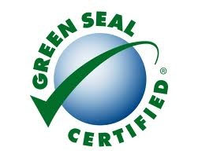

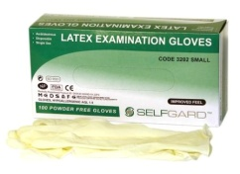

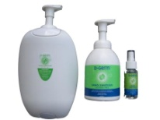

**Hand sanitiser –** Alcohol free and fragrance free, foaming hand sanitiser.

500ml desktop $10.50 2.5L refill $38.50 Wall dispenser FOL

**TOILET PAPER**

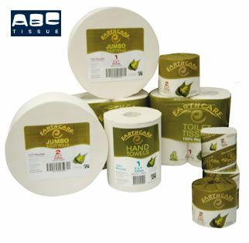

**Earthcare Toilet Paper –** made from 100% recycled paper. Soft, strong and white. Environmental Choice Australia Certification. 400sh individual wrapped

1ply, 850 sheet, 48 rolls $44.00 Interleaf tissue 9000sheet $62.40  
2ply, 400 sheet, 49 rolls $37.80 - interleaf also good for **tissues**

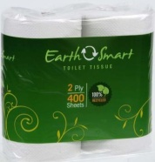

**Coastal Toilet Paper** – made from 100% recycled paper. Individually wrapped.

2ply, 400 sheet, 48 rolls $37.80

**Earthsmart Toilet Paper –** made from 100% recycled.

1ply, 850 sheet, 48 rolls $45.90  
2ply, 400 sheet, 48 rolls $41.85

[See full size image](http://www.nicma.co.nz/images/logo.png)

**PAPER TOWELS**

**Earthsmart Paper Towels** – Slimfold ‘Z’ fold – made from 100% recycled paper.

Carton 4000sheets $57.50

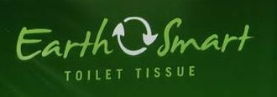

**Coastal Paper Towels** – 50/50 recycled paper

Midfold 4000sheets $53.60 Slimfold 4000sheets $53.60

**[See full size image](http://www.nicma.co.nz/images/logo.png)**

**Coastal Half wipe Paper Towels –** half the size of normal paper towels – ideal for small hands. 50% recycled paper

Slimfold 8000 sheets $58.29

**[See full size image](http://www.nicma.co.nz/images/logo.png)**

**TISSUE PAPER**

**Earthcare Tissues –** made from 100% recycled paper and are still soft and white.

Box 200’s $2.10 Carton 32 boxes $64.00

**F:\Insinc Products\ABC\ABC\Earthcare tissues2.jpg**



**Earthcare Interleaf Tissues** – made from 100% recycled paper, use in a wall dispenser so you always know where the tissues are.

Carton 9000sheets $62.40

**SANITARY UNITS/NAPPY BIN**

**Sanitary Units – Disposable** – made from 80% recycled materials. No expensive contracts. Sanitising sachet will last a minimum of 1 month, killing odours and germs. When full simply throw out the whole bin with your normal rubbish.

6Litre size $9.50 12Litre $12.00 Nappy bin also available $11.00 (line with bag)

.

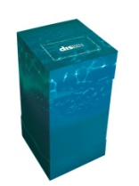



**We have many other products and sizes available, please check out our website or call us on 0508 467 462**